*MicroService Concept*

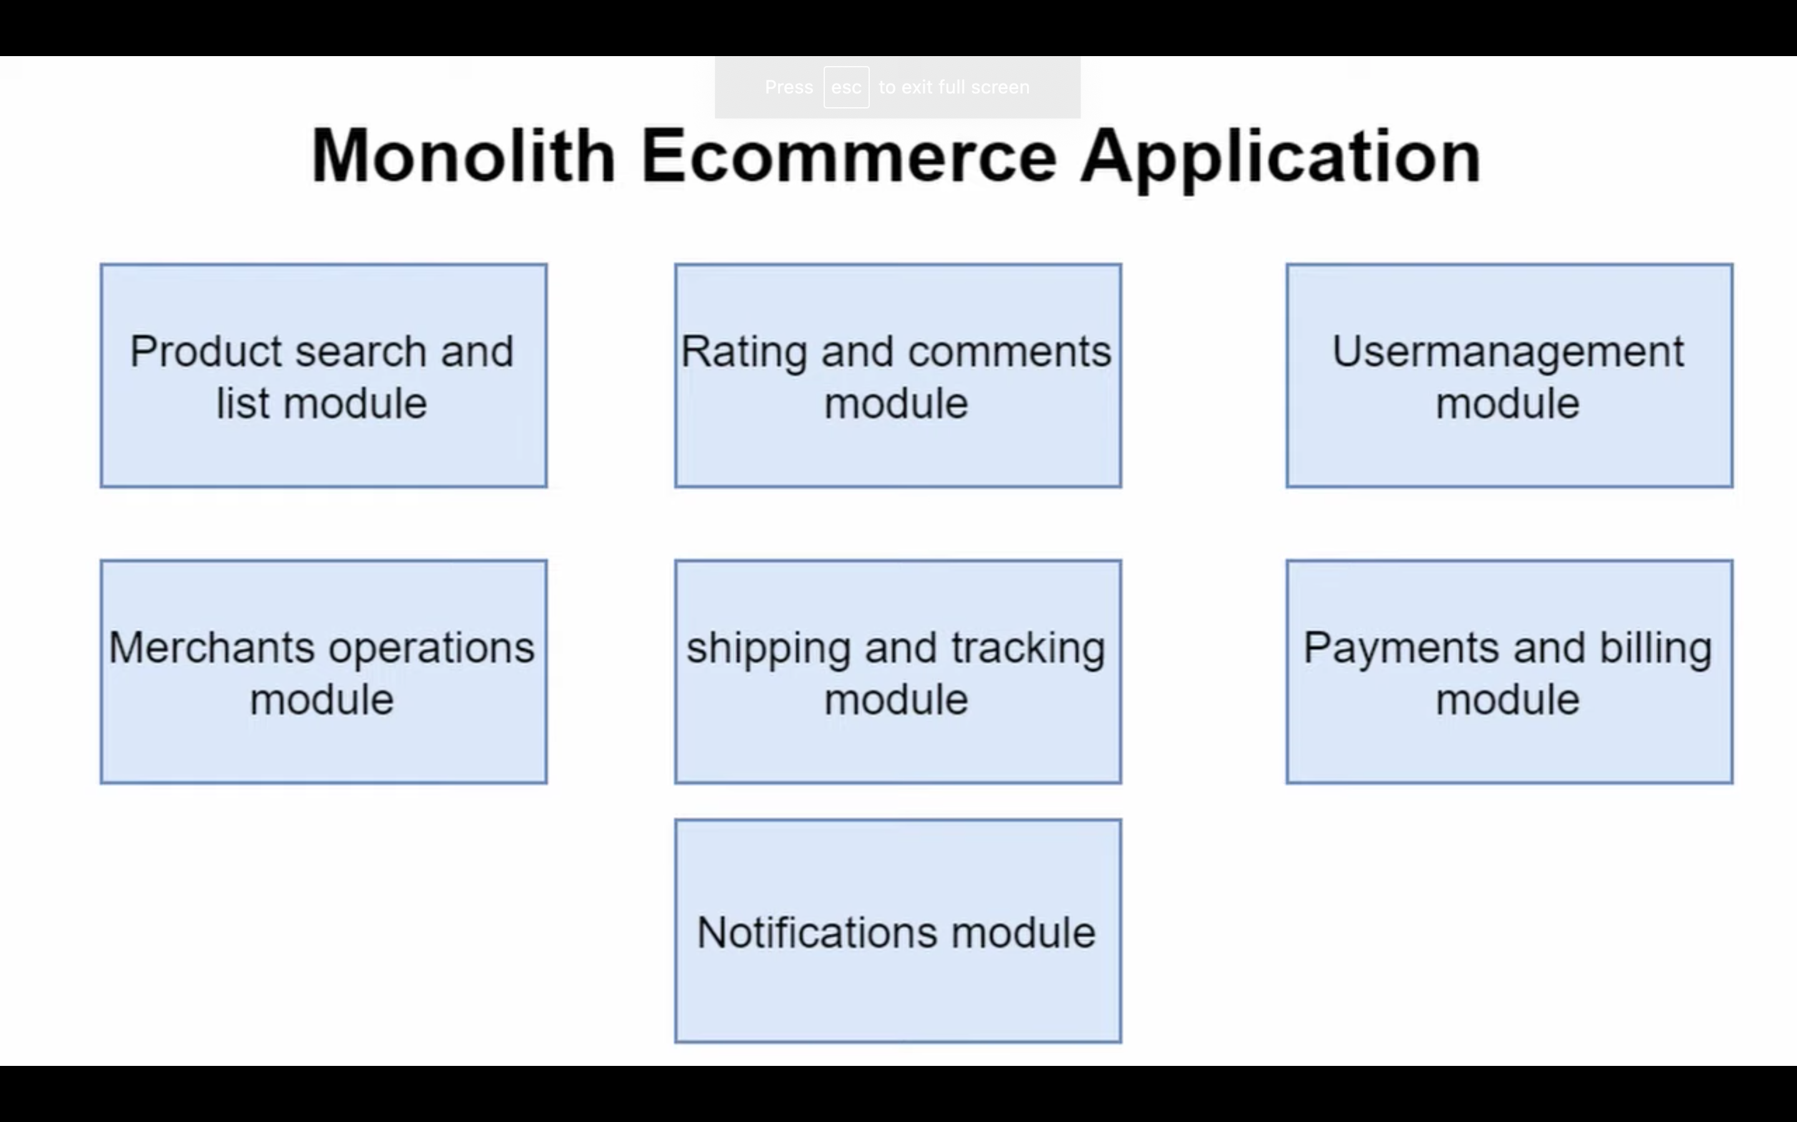

Drawbacks

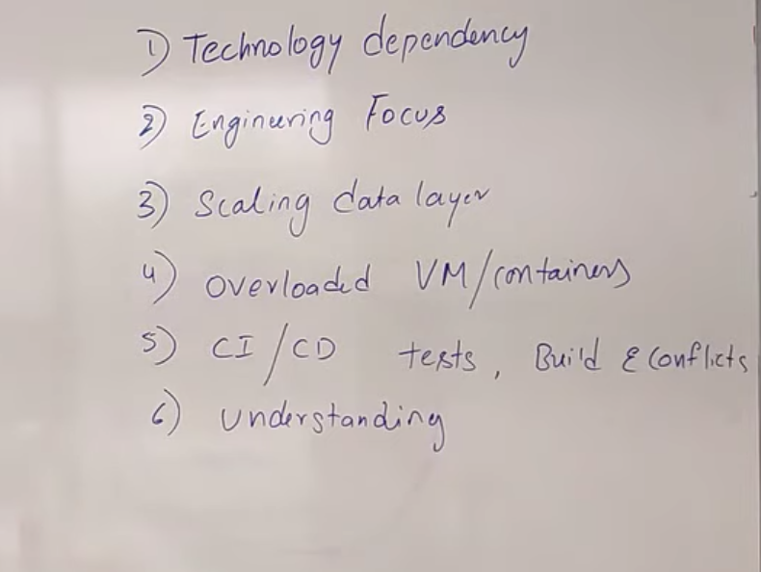

Monolith = like A big rock

Simple (One server)- Develop- deploy-scale

LB (scaling) - server1

- server 2

not good for millions of users

Micro-Service Architectiure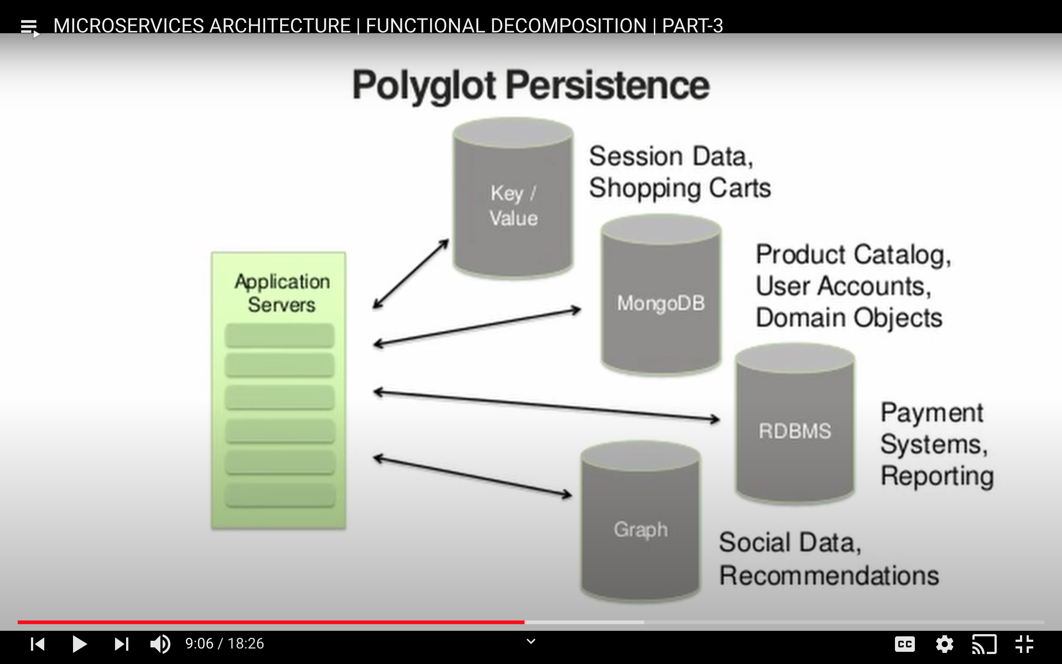

Advantages MS:-

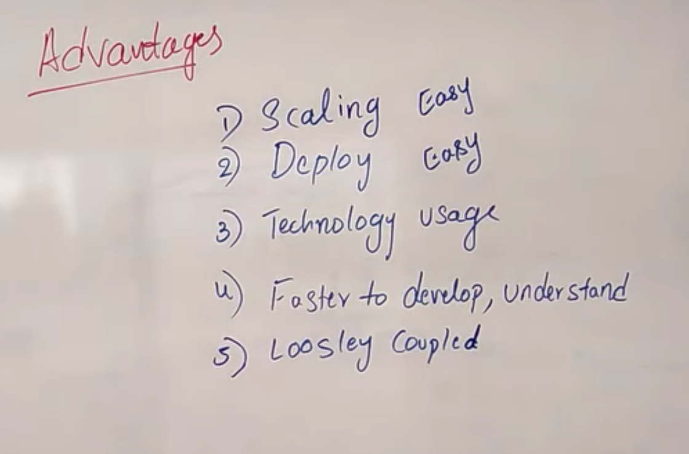

Disadvantage:

Jegger UI for debugging

Still we go as with MS for high availability

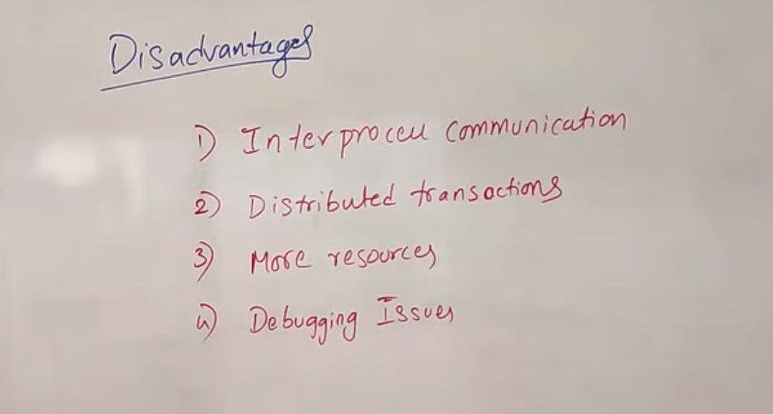

Scale MS



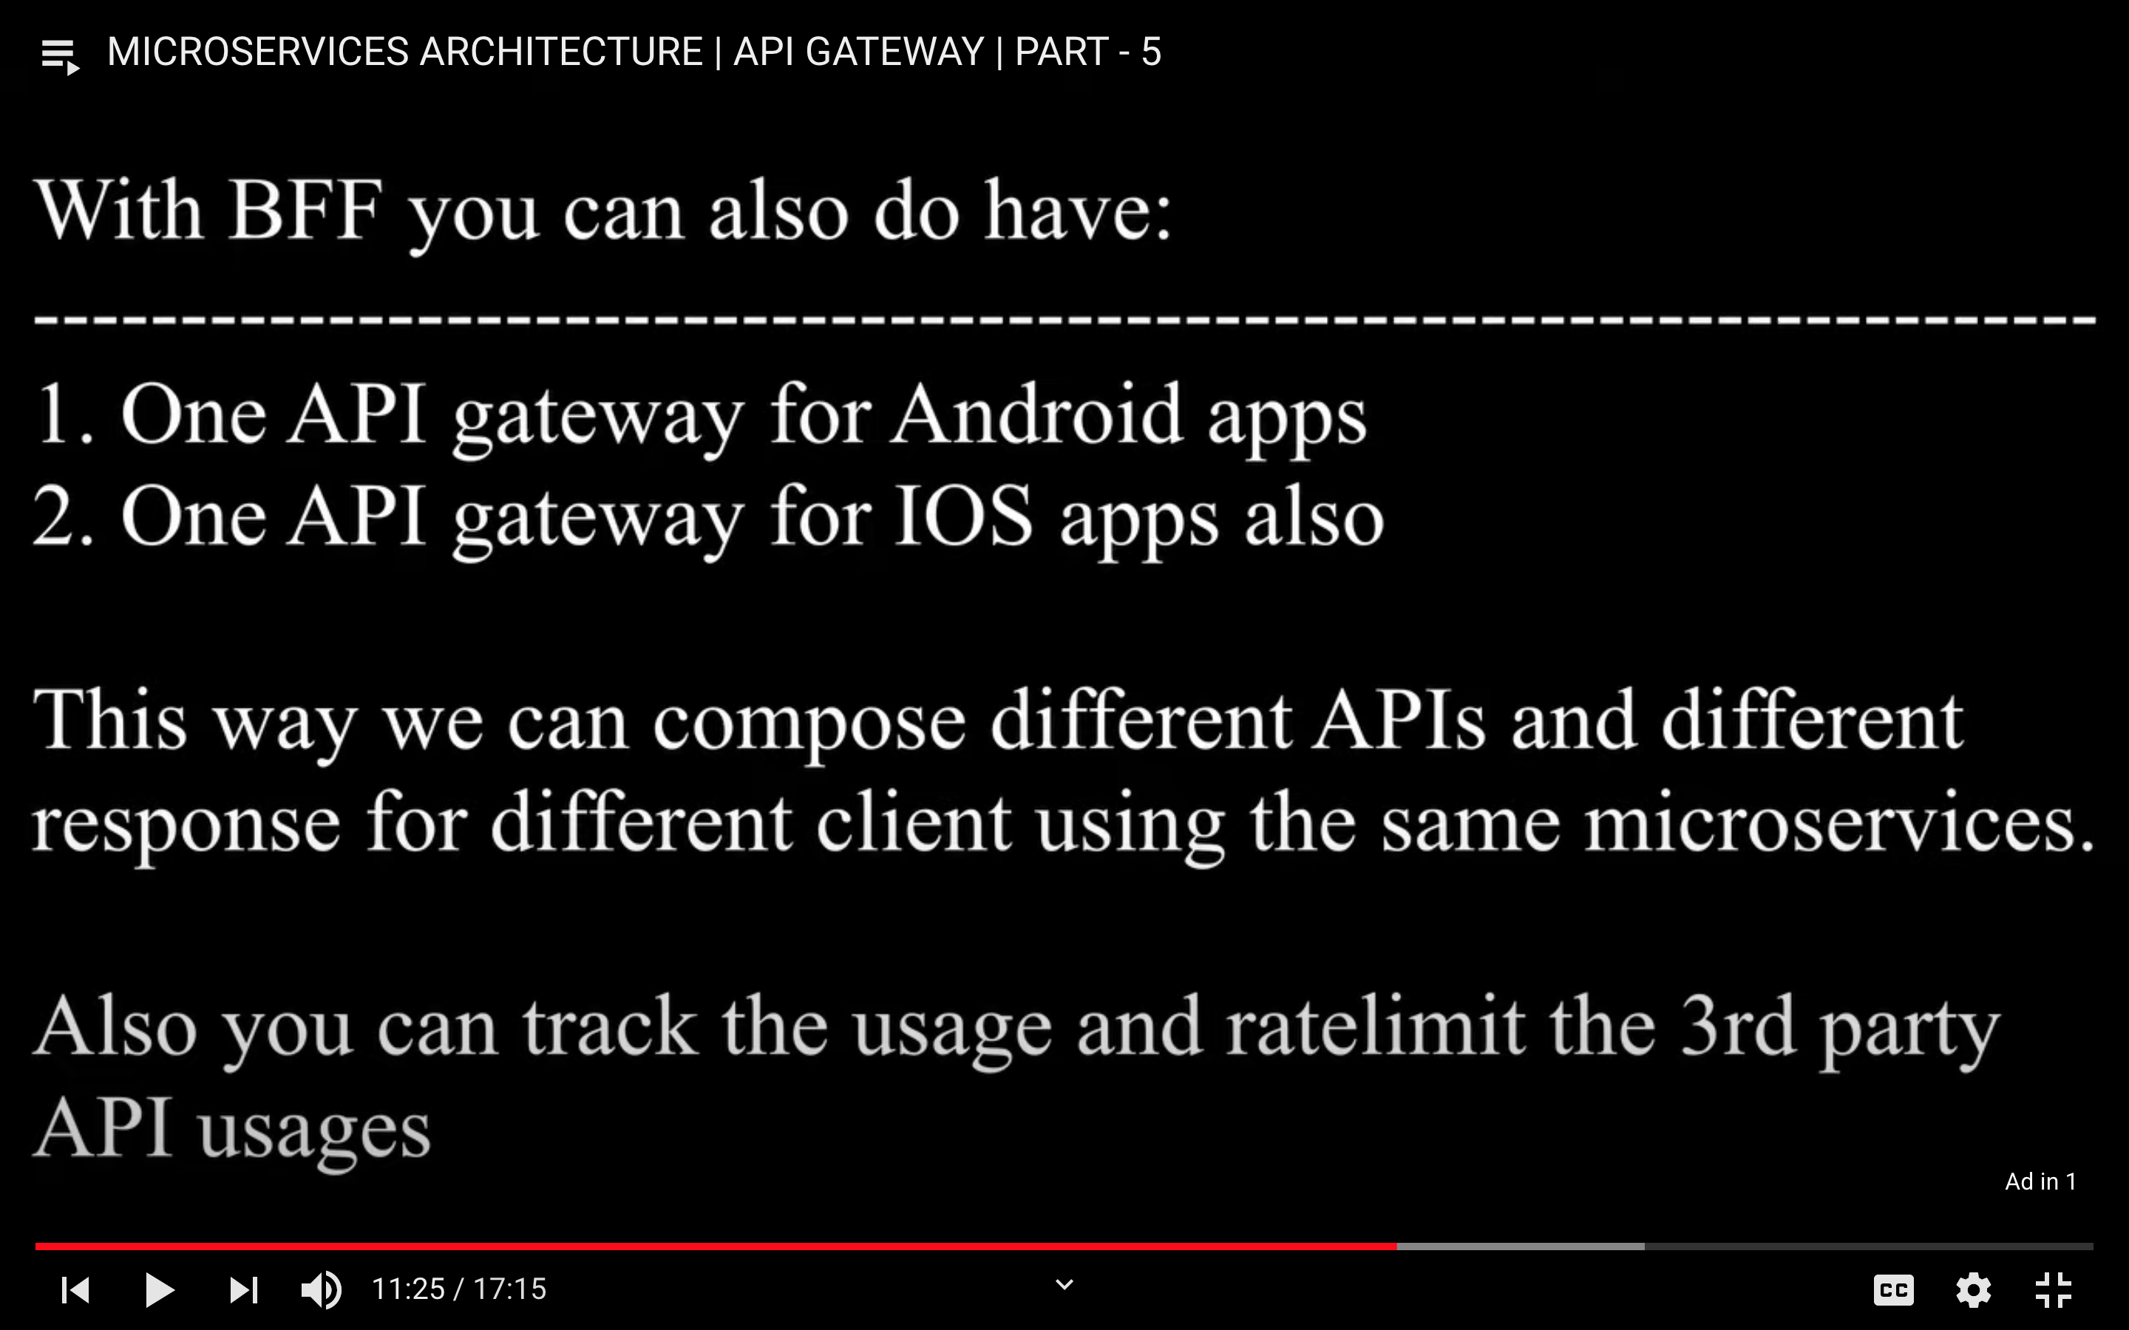

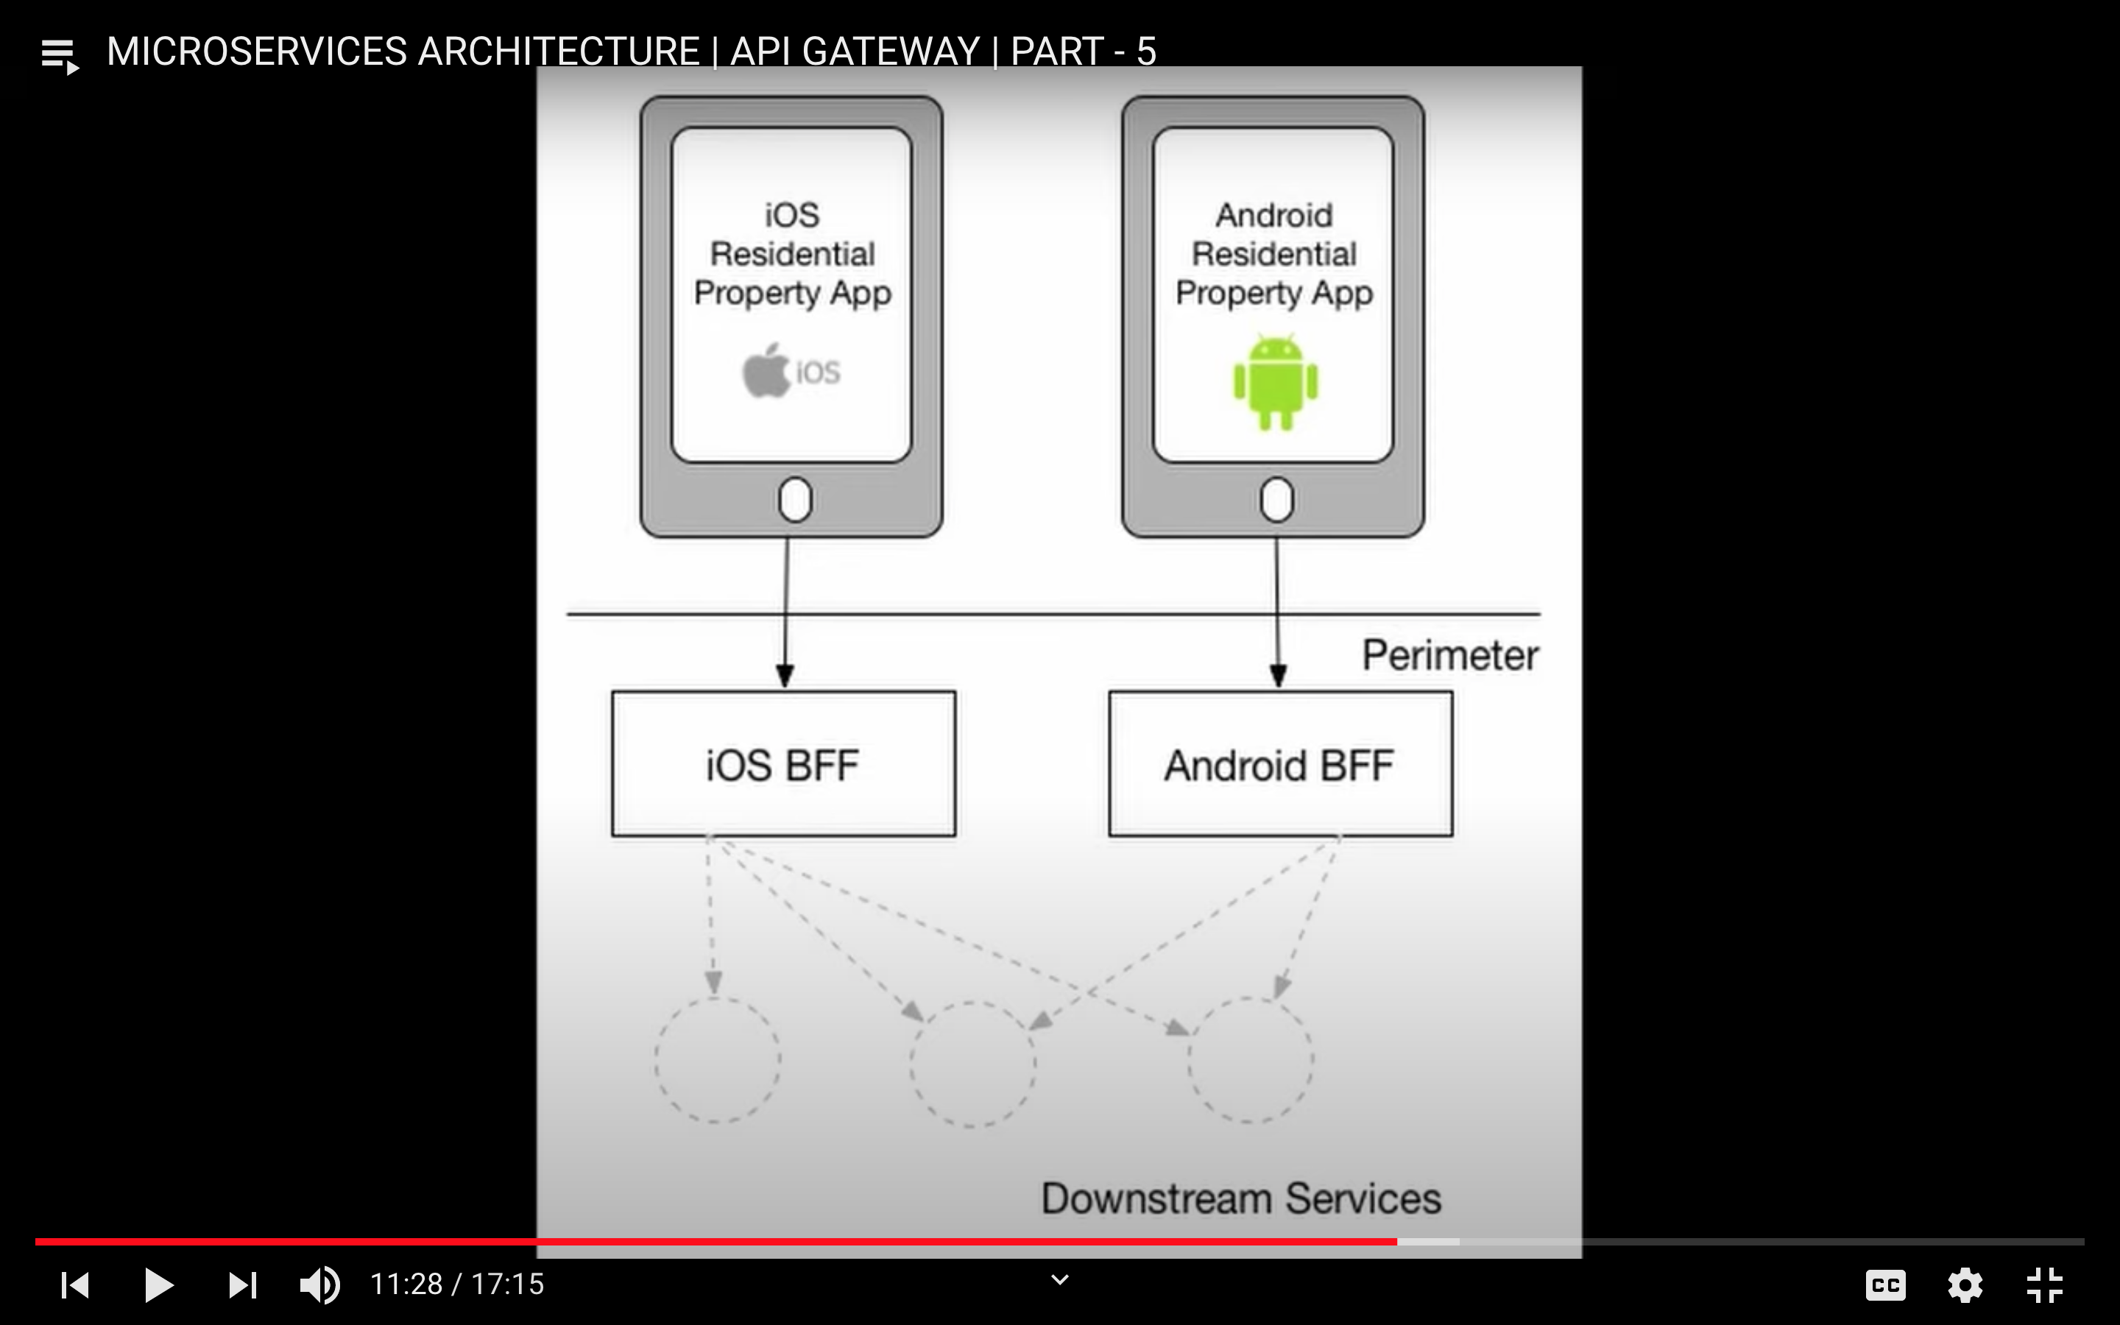

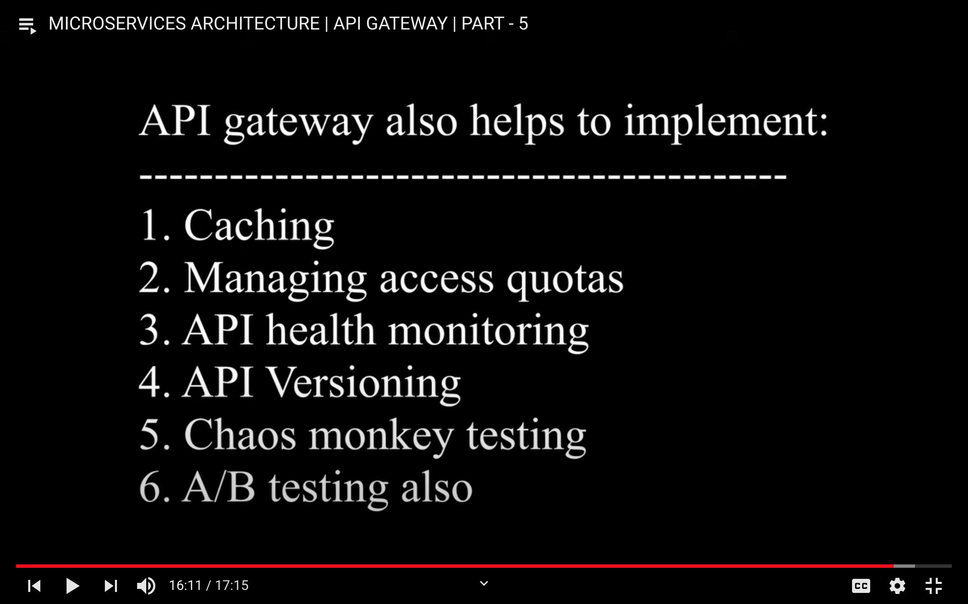



Service registry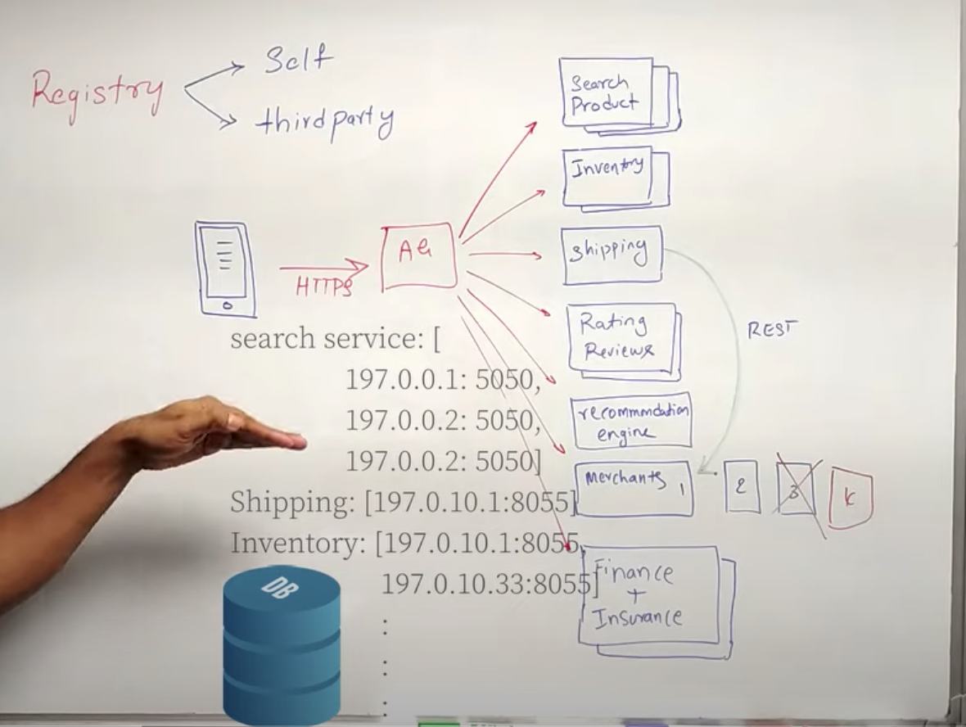

Registry

1.Self registry- all MS self register to register DB

2.Third party - Registry DB will ask to all MS for thr netwotk address.

-Whom SR will ask ? - It checks all the cluster evenst while scaling the MS.

Asynchronous call to microservices – with help of queue.

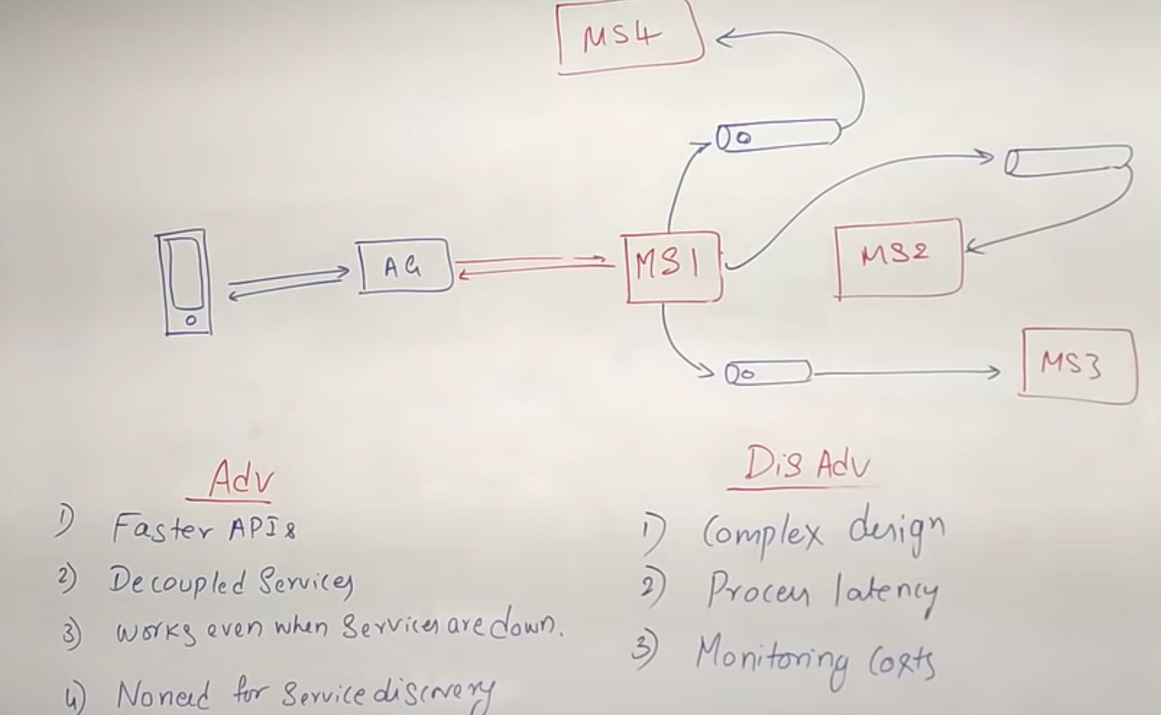

CIRCUIT BREAKING

-------------------

Overload MService will not serve the request- throw error - Require circuit breaking

1. return cache response - previous successfull response

2. fallback mechanism- 3rd party will provide instead of MS3 fails

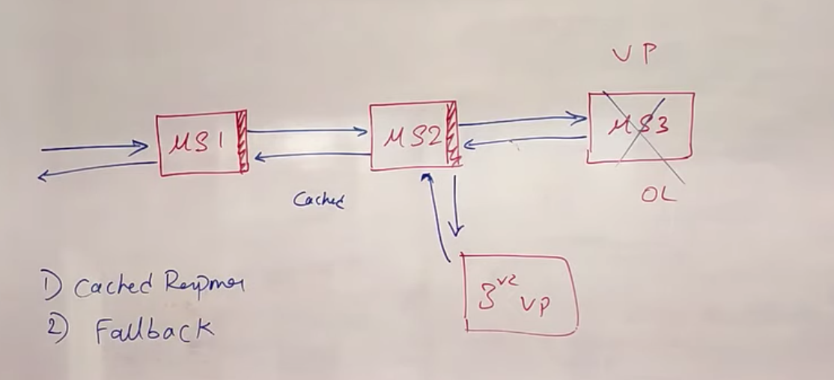

3. Healing by disconnecting MS# to recover fast (like 5 min)

- again try to connect after 5 min if healed (Recovered).

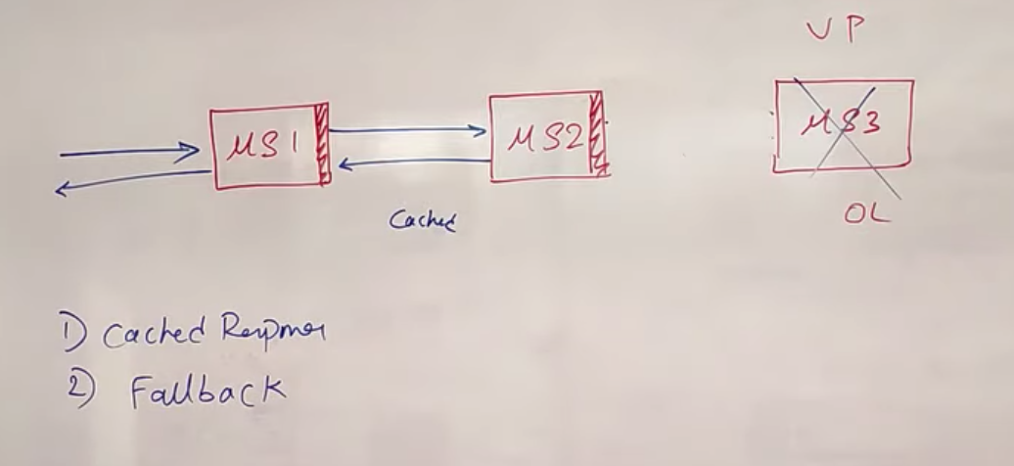

Service Mesh

